# of samples tested | # of samples with detectable insecticides | % of samples with detectable insecticides
632 | 223 | 35.28%
# of non-mig samples tested | # of non-mig samples with detectable fungicides | % of non-mig samples with detectable fungicides
442 | 139 | 31.45%
Insecticides Analysis

(Method: summary stats)
2010-2013 | n | Mean | St. Dev | Min | Max | Percent infected at detectable level | Percent infected at threshold level | t-stat | p-value
Mites per 100 bees (Insecticides) | 198 | 5.14 | 6.24 | 0 | 31.40 | 87.88% | 48.99% | -0.16 | 0.88
Mites per 100 bees (No insecticides) | 377 | 5.22 | 5.65 | 0 | 37.16 | 93.10% | 54.64% | -0.16 | 0.88
Nosema per bee (Insecticides) | 196 | 0.38 | 0.85 | 0 | 7.95 | 55.61% | 13.27% | 0.52 | 0.60
Nosema per bee (No insecticides) | 377 | 0.34 | 0.91 | 0 | 10.8 | 45.09% | 10.61% | 0.52 | 0.60

Morbidity Summary Statistics (migratory + non-migratory)

(Method: Basic t-stats)

Top Landcovers (t-stat)

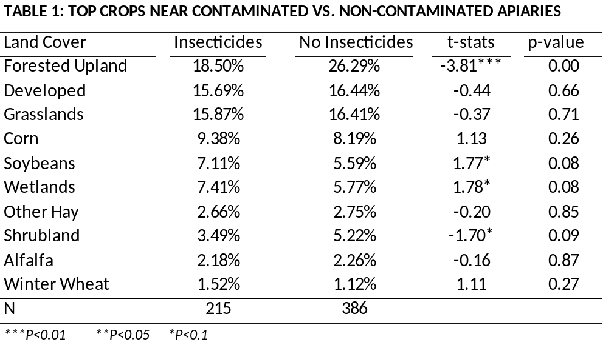

Detection Time and Location
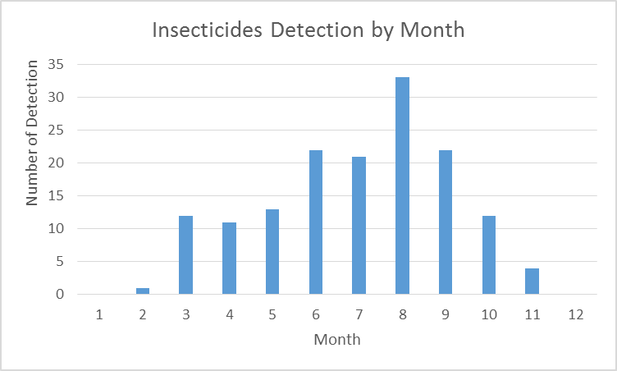
Month | Count
Jan | 0
Feb | 4
Mar | 11
Apr | 12
May | 21
Jun | 19
Jul | 30
Aug | 37
Sep | 50
Oct | 28
Nov | 11
n=223
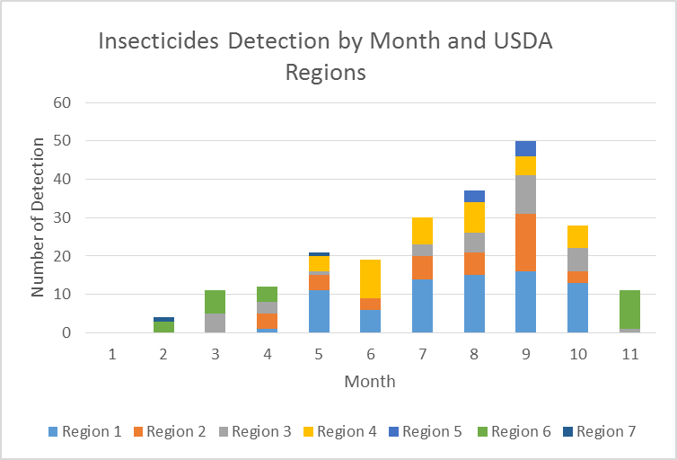

The detection of insecticides is roughly on an increasing trend till September. Among the 223 apiaries contaminated by insecticides, 76 were from Region 1. In Feb and Mar, detection mainly appeared in CA and FL, then it gradually moved to the midwest (IL, OK, IN, NE and etc) from April to June. From July, insecticides started to be detected in cooler states such as NY and NJ.

